## Denormalize ABC_Retail tables

See the code file **denormalize_abc_retail.sql**

**Check the result:**

Table **raw** is the table that we imported the original ABC_Retail.csv 2 weeks ago.

Table **ABC_Retail** is the table which we de-normalize all data from other tables and insert into it.

-- create table

CREATE TABLE abc_retail.ABC_Retail(

OrderID int,

OrderDate date default null,

Order_ShippedDate date default null,

Order_Freight numeric(20,2),

Order_ShipCity varchar(255),

Order_ShipCountry varchar(255),

Order_UnitPrice numeric(20,2),

Order_Quantity numeric(20,2),

Order_Amount numeric(20,2),

ProductName varchar(255),

Employee_LastName varchar(255),

Employee_FirstName varchar(255),

Employee_Title varchar(255),

CompanyName varchar(255),

Customer_ContactName varchar(255),

Customer_City varchar(255),

Customer_Country varchar(255),

Customer_Phone varchar(255)

);

-- denormalize tables into table ABC_Retail

INSERT INTO abc_retail.ABC_Retail

(

    OrderID, OrderDate, Order_ShippedDate, Order_Freight, Order_ShipCity,

    Order_ShipCountry, Order_UnitPrice, Order_Quantity, Order_Amount,

    ProductName, Employee_LastName, Employee_FirstName, Employee_Title,

    CompanyName, Customer_ContactName, Customer_City, Customer_Country,

    Customer_Phone

)

(

    SELECT DISTINCT

        o.order_id, o.order_date, o.order_shippeddate, o.order_freight,

        o.order_shipcity, o.order_shipcountry,

        opp.order_unitprice, opp.order_quantity, opp.order_amount,

        opp.product_name,

        e.employee_lastname, e.employee_firstname, e.employee_title,

        cocu.company_name,

        cocu.customer_contactname, cocu.customer_city, cocu.customer_country,

        cocu.customer_phone

    FROM abc_retail.orders AS o

    JOIN abc_retail.employees as e

    ON o.employee_id = e.employee_id

    JOIN

    (

        SELECT DISTINCT

            cu.customer_id,

            co.company_name,

            cu.customer_contactname, cu.customer_city, cu.customer_country,

            cu.customer_phone

        FROM abc_retail.companys AS co

        JOIN abc_retail.customers AS cu

        ON co.company_id = cu.company_id

    ) AS cocu

    ON o.customer_id = cocu.customer_id

    JOIN

    (

        SELECT DISTINCT

            op.order_id, op.order_unitprice, op.order_quantity, op.order_amount,

            p.product_name

        FROM abc_retail.order_products AS op

        JOIN abc_retail.products AS p

        ON op.product_id = p.product_id

    ) AS opp

    ON o.order_id = opp.order_id

);

Check number of data in table **raw**.

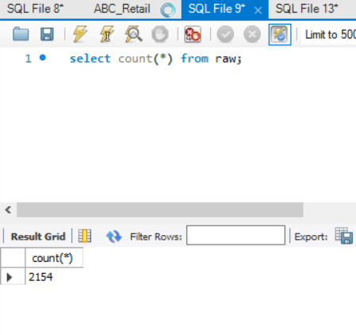

Check number of data in table **ABC_Retail**.

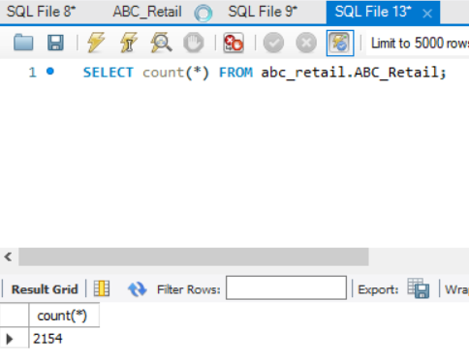

Data in table **raw**.

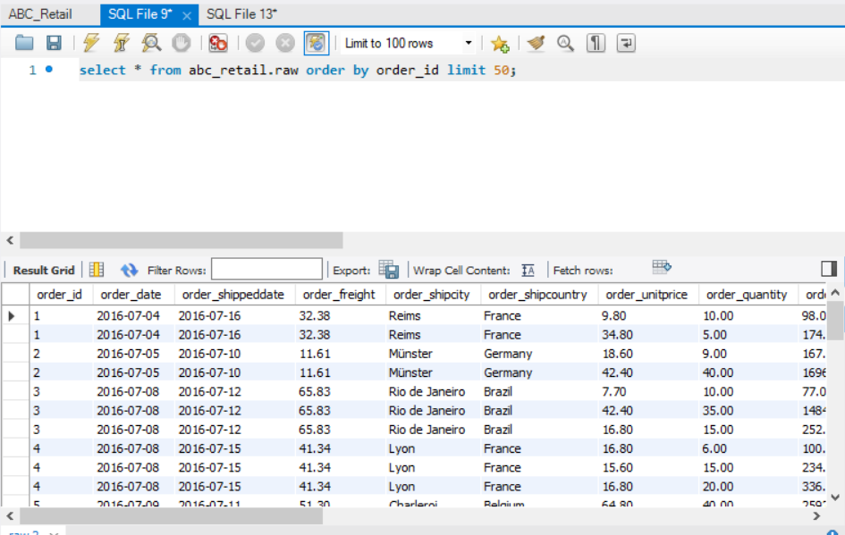

Data in table **ABC_Retail**.

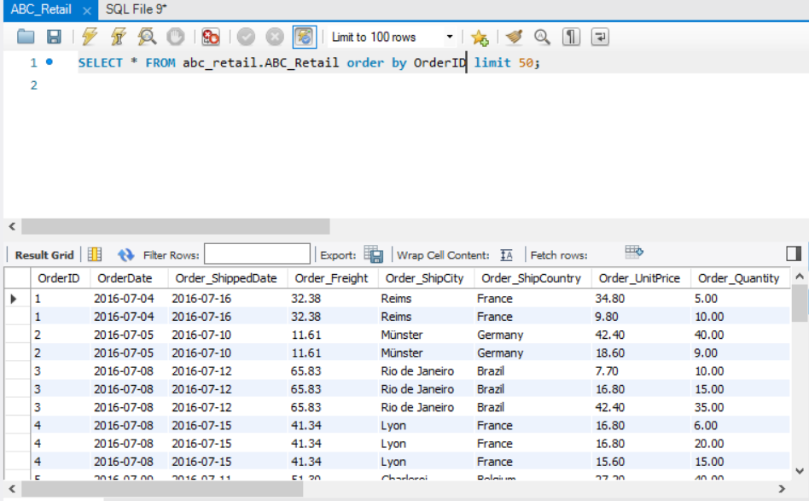

## Create MyCube table from the denormalized table

Since **select … into** is not valid in our MySQL version, detail reasons could be found at <https://stackoverflow.com/questions/2949653/select-into-and-undeclared-variable-error>

We just use **create** then **insert into … select …**

-- create table

CREATE TABLE abc_retail.MyCube(

    ThisYear year default null,

    Region varchar(255),

    Product varchar(255),

    Sales numeric(20,2)

);

-- Create MyCube table from the denormalized table

INSERT INTO abc_retail.MyCube

(

    ThisYear, Region, Product, Sales

)

SELECT

    year(OrderDate) as ThisYear

    ,Order_ShipCountry as Region

    ,ProductName as Product

    ,Order_Amount as Sales

FROM

    abc_retail.ABC_Retail

WHERE

    Order_ShipCountry in ('USA','Canada','UK')

    and ProductName in ('Chai','Tofu','Chocolade');

Check the result:

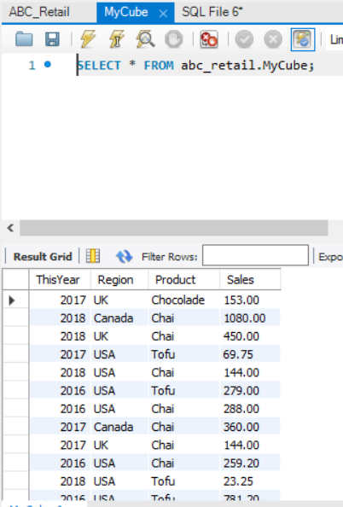

## Run all the attached OLAP Operators against the newly created MyCube table

The following OLAP operators could be run in our MySQL database.

And other operations like the **PIVOT** operators could not be run on MySQL.

-- table

select * from MyCube order by 1,2,3

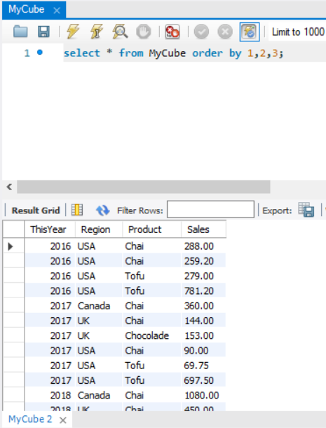

-- slicing

select * from MyCube where ThisYear=2016

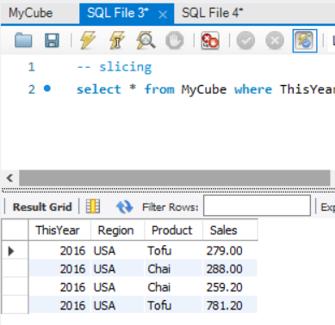

-- dicing

select * from MyCube where ThisYear=2016 and region='USA'

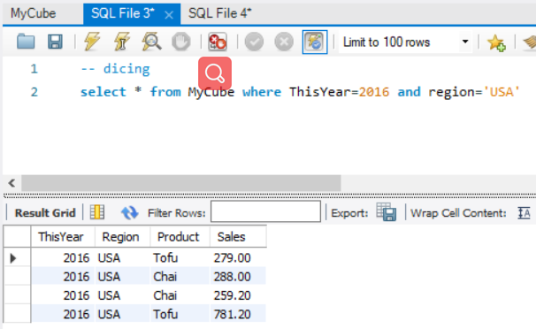

-- group by with rollup

SELECT ThisYear, Region, Product, SUM(Sales)as TotalSales--, GROUPING(ThisYear) AS 'Grouping'

FROM MyCube

GROUP BY ThisYear, Region, Product with rollup

ORDER BY 1,2,3

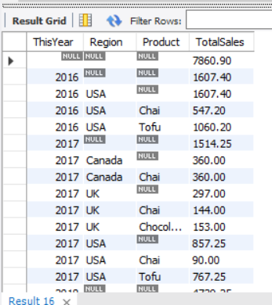 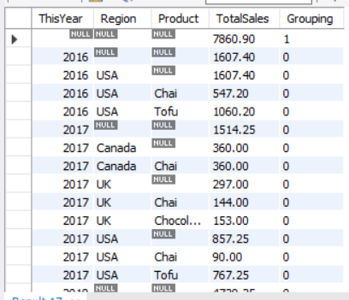

-- group by with cube

SELECT ThisQuarter, Region, Product, SUM(Sales)  
as TotalSales--, GROUPING(ThisQuarter) AS 'Grouping'

FROM MyCube

GROUP BY ThisQuarter, Region, Product with cube

ORDER BY 1,2,3

Could be write as:

(

    SELECT ThisYear, Region, Product, SUM(Sales)as TotalSales--, GROUPING(ThisYear) AS 'Grouping'

    FROM MyCube

    GROUP BY ThisYear, Region, Product with rollup

    UNION

    SELECT ThisYear, Region, Product, SUM(Sales)as TotalSales--, GROUPING(ThisYear) AS 'Grouping'

    FROM MyCube

    GROUP BY ThisYear, Product, Region with rollup

    UNION

    SELECT ThisYear, Region, Product, SUM(Sales)as TotalSales--, GROUPING(ThisYear) AS 'Grouping'

    FROM MyCube

    GROUP BY Region, ThisYear, Product with rollup

    UNION

    SELECT ThisYear, Region, Product, SUM(Sales)as TotalSales--, GROUPING(ThisYear) AS 'Grouping'

    FROM MyCube

    GROUP BY Region, Product, ThisYear with rollup

    UNION

    SELECT ThisYear, Region, Product, SUM(Sales)as TotalSales--, GROUPING(ThisYear) AS 'Grouping'

    FROM MyCube

    GROUP BY Product, ThisYear, Region with rollup

    UNION

    SELECT ThisYear, Region, Product, SUM(Sales)as TotalSales--, GROUPING(ThisYear) AS 'Grouping'

    FROM MyCube

    GROUP BY Product, Region, ThisYear with rollup

)

ORDER BY 1,2,3;

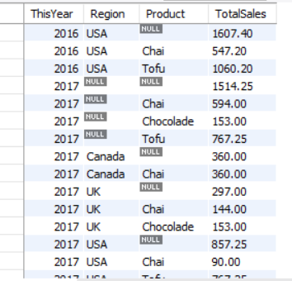 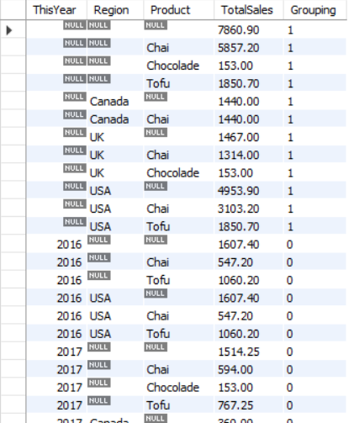

-- group by grouping sets

SELECT ThisQuarter, Region, SUM(Sales) as TotalSales

FROM MyCube

GROUP BY GROUPING SETS ((ThisQuarter), (Region))

ORDER BY 1,2

Is the same as:

--

SELECT ThisYear, NULL as Region, SUM(Sales) as TotalSales FROM MyCube GROUP BY ThisYear

UNION ALL

SELECT NULL, Region, SUM(Sales) as TotalSales FROM MyCube GROUP BY Region

ORDER BY 1,2

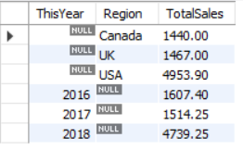

-- Ranking

SELECT

    Product, Sales

    , RANK() OVER (ORDER BY Sales ASC) as RANK_SALES

    , DENSE_RANK() OVER (ORDER BY Sales ASC) as DENSE_RANK_SALES

    , PERCENT_RANK() OVER (ORDER BY Sales ASC) as PERC_RANK_SALES

    , CUME_DIST() OVER (ORDER BY Sales ASC) as CUM_DIST_SALES

FROM

    MyCube

ORDER BY

    RANK_SALES ASC

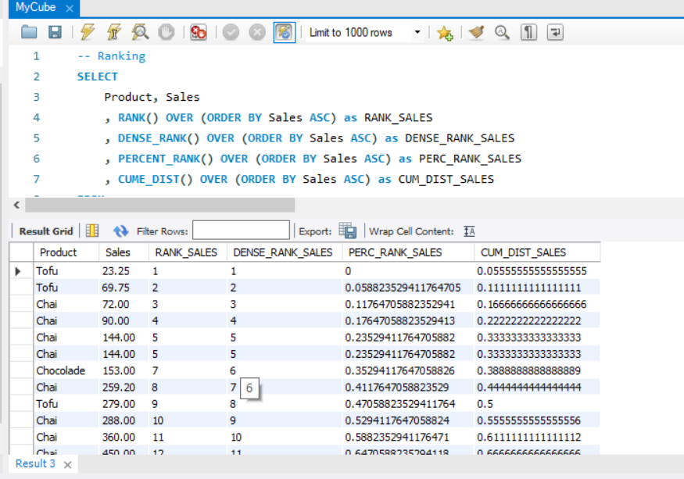

-- Windowing

SELECT

    ThisYear, Region, Sales

    , AVG(Sales) OVER (PARTITION BY Region ORDER BY ThisYear) AS Sales_Avg

FROM

    MyCube

ORDER BY

    Region, ThisYear, Sales_Avg

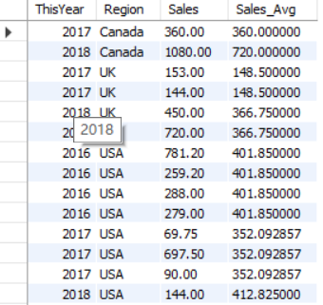

-- Windowing

SELECT

    ThisYear, Region, Sales

    , AVG(Sales) OVER (PARTITION BY Region ORDER BY ThisYear ROWS BETWEEN 1 PRECEDING AND 1 FOLLOWING) AS Sales_Avg

FROM

    MyCube

ORDER BY

    Region, ThisYear, Sales_Avg

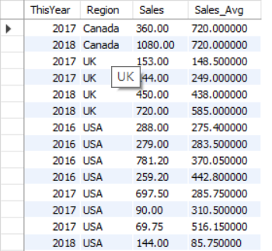

## If your DBMS does not support PIVOT, write a SQL script to produce the same result

Our DBMS is MySQL server.

-- pivot query

select

    Product, Q1, Q2, Q3, Q4

from

    MyCube PIVOT(SUM(Sales) FOR ThisQuarter IN (Q1,Q2,Q3,Q4)) AS P

Could be write as:

-- pivot query

select

    Product,

    SUM( IF(ThisYear=2016,Sales,0) ) As `2016`,

    SUM( IF(ThisYear=2017,Sales,0) ) As `2017`,

    SUM( IF(ThisYear=2018,Sales,0) ) As `2018`,

    SUM(Sales) As 'ALL'

from MyCube

group by Product with rollup;

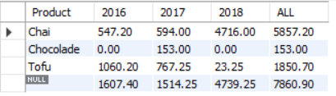

-- pivot query

SELECT Product, Region, Q1, Q2, Q3, Q4

FROM

(SELECT Product, Region, ThisQuarter, Sales FROM MyCube) AS p

PIVOT

(sum(Sales) FOR ThisQuarter IN (Q1,Q2,Q3,Q4)) AS pvt

Could be write as:

SELECT

    Product,

    Region,

    sum( IF(ThisYear=2016,Sales,0) ) As `2016`,

    sum( IF(ThisYear=2017,Sales,0) ) As `2017`,

    sum( IF(ThisYear=2018,Sales,0) ) As `2018` ,

    sum(Sales) As 'ALL'

FROM

(SELECT Product, Region, ThisYear, Sales FROM MyCube) AS p

GROUP BY Product, Region WITH ROLLUP;

